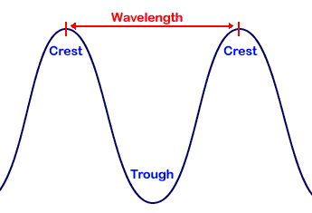
Wavelength – the distance between one crest and the next crest, or one trough and the next trough on a wave.

Colour – the light reflected off an object. For example, a red apple looks red because all the colours of white light are absorbed into the apple, except for red light which is reflected off it and passes into our eyes.

Dispersion – white light being split into the seven different colours.

Spectrum – the pattern of colours which make up white light.

Speed of light – light travels at 300 000 kilometres per second.
Reflection – the bouncing of light off a surface.

Regular reflection – parallel rays of light that hit a smooth surface and are reflected parallel to each other. For example, mirror.
Irregular reflection (diffuse reflection) – parallel light rays that hit a rough surface and are reflected in all directions. Example, newspaper.

Ray diagram – diagram that shows the incident ray and reflected ray off a surface.
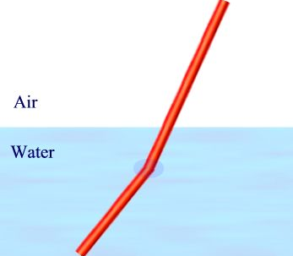
Refraction – the bending of light that happens when light passes through one substance and into another.

Transparent – Transparent materials allow all light to pass through it. Example, glass window.

Translucent – Translucent materials let some light through. Example, tissue paper.

Opaque – Opaque materials do not allow light to pass through them. They either block or absorb the light. Example, cardboard.

Shadow – an opaque object blocking light from covering an area.

